

Nupur Chakraborty

AIONOS INDIA PVT LIMITED  [Company address]

AI-Driven Conversational Assistant for Supply Chain Management

Context & Background 2

Objectives & Scope 2

Scenario for POC 2

High Level Architecture 3

Calculate Coal Requirement 3

Out of Scope for POC 4

Key Deliverables 4

Outputs and Client Value from the POC 4

Business Benefits & Value Proposition 5

Data Requirements 5

Risks & Mitigation 5

LLM Guardrails Framework for On-Prem Deployment 6

POC Execution Options 7

Excel-Based Data Sharing 7

Architecture 7

Flow for NTPC’s on-demand charts generation in the application – *(This can be discussed and agreed upon)* 8

POC Timeline 9

Overall Understanding from the shared Dataset (Dadri Data) 10

1. Coal Procurement EDA 10

2. Coal GCV EDA 11

Commercials 13

## Context & Background

NTPC faces increasing challenges in optimizing coal procurement and supply chain operations due to fluctuating demand, variable coal quality, transportation risks, and the need to balance cost efficiency with production reliability. The AI-driven conversational assistant proposed in this POC is designed to enhance operational decision-making by leveraging real-time data, predictive analytics, and scenario-based planning.

## Objectives & Scope

The objective of this Proof of Concept (POC) is to validate the feasibility and effectiveness of an AI system that can calculate coal requirements, manage coal inventory buffers, and optimize procurement decisions under varying operational scenarios. The scope includes coal requirement calculations, route and climate risk evaluation, grade/blend optimization, cost analysis, plant efficiency and logistics planning.

## Scenario for POC

**Problem statement**: *Optimization of coal cost to manage the electricity demand for a given plant load factor.*

The POC will validate the AI system’s ability to address a limited subset of operational scenarios and decision-making challenges, including:

* Manual entry of electricity demand by NTPC teams.
* Estimating coal quantity needed for daily electricity generation using demand and basic efficiency factors.
* Maintaining a minimum 10–20 day emergency stock at a simplified level (no over-optimization).
* Basic assessment of transportation risks (e.g., generic delay factor) and adjustments.
* Demonstrating simple visualization of coal requirement, stock, and demand alignment
* Enable Natural Language Interaction to generate dynamic visualization (graphs, charts)

# High Level Architecture

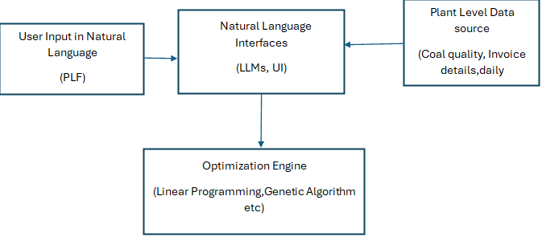

*Fig 1: Components of high-level architecture*

#### Calculate Coal Requirement

*Fig 2: Coal requirement parameters*

In this limited POC, the AI-driven system will calculate coal requirement by considering a restricted set of parameters. The projection will be made on a smaller dataset and fewer operational dimensions.

1. Demand & Generation Parameters
   * Input electricity demand (manual entry).
   * Plant load factor (basic efficiency adjustment).
2. Coal Quality Parameters
   * Calorific value (GCV/NCV only).
3. Cost Parameters
   * Base commodity cost of coal (domestic/imported sample values).
4. Stock Parameters
   * Current coal stock levels (basic tracking).
   * Minimum emergency buffer of 10–20 days.
5. Decision Gates (Simplified)
   * Profitability check (tariff vs delivered cost at a broad level).
   * Buffer gate (minimum stock levels maintained).

## Out of Scope for POC

* Detailed blending optimization.
* Complete logistics modeling (rack/rail, unloading/handling capacities).
* Full risk modeling (weather, supplier reliability, route disruptions).
* Comprehensive compliance and emission checks.
* Multi-parameter financial optimization.

## Key Deliverables

* Limited dataset validation (sample demand, stock, and cost records).
* Basic prediction model for coal requirement (target ~80% accuracy).
* Simple dashboard visualizing demand, coal requirement, and stock.
* Quick-win demonstration of feasibility within 4–6 weeks.

## Outputs and Client Value from the POC

Upon completion of the POC, NTPC can expect the following outputs and value insights:

* A functional AI decision loop model capable of running daily procurement and energy planning cycles.
* A cost-benefit analysis report comparing AI-optimized procurement vs. current manual methods.
* Optimized coal blend plans for varying demand and climate scenarios.

## Business Benefits & Value Proposition

Implementing this AI-driven solution is expected to deliver measurable benefits to NTPC, including:  
- Reduction in procurement costs by optimizing sourcing decisions.  
- Improved reliability of coal supply through proactive risk management.  
- Maintenance of optimal emergency stock buffers (10–20 days) without overstocking.  
- Enhanced profitability by ensuring procurement costs remain lower than production revenue.  
- Increased operational agility through real-time decision support and automated scenario analysis.

## Data Requirements

The POC will operate using structured datasets covering at least 30–50 parameters in the following categories:  
- Coal Quality Data  
- Cost & Price Data  
- Logistics Data  
- Stock & Buffer Data

Data will be provided in Excel format for ease of collection and processing during the POC phase.

## Risks & Mitigation

- Data quality or completeness issues → Mitigation: Data validation and cleansing before model runs.  
- Weather-induced transportation delays → Mitigation: Alternative sourcing and route plans.  
- Limited historical data for certain scenarios → Mitigation: Scenario modelling and synthetic data.  
- Resistance to AI recommendations → Mitigation: Stakeholder training and change management.

## LLM Guardrails Framework for On-Prem Deployment

To ensure that the LLM operates within controlled boundaries delivering quality responses while mitigating risks such as code hallucination, security exposure, or compliance violations.

|  |  |  |
| --- | --- | --- |
| **Category** | **What to Configure** | **Why It Matters** |
| **Input Validation** | • Sanitize all user inputs  • Block prompt injection or code injection | Prevents malicious or malformed prompts |
| **Prompt Templates** | • Use structured prompts with placeholders  • Restrict "freeform" generation | Ensures predictable output aligned with use case |
| **Output Filtering** | • Scan LLM responses for banned functions, harmful code, or hallucinated logic | Protects against insecure or irrelevant code generation |
| **Context Limiting** | • Set token or character limits  • Scope to specific SDK functions/fields | Prevents model overreach and ensures domain relevance |
| **Audit Logging** | • Log all LLM interactions  • Include prompt, timestamp, user ID | Enables traceability, troubleshooting, and governance |
| **Rate Limiting** | • Throttle requests per user/session | Avoids overload, DoS risk, and resource abuse |
| **Role-Based Access** | • Gate functionality based on user roles (e.g., junior devs vs architects) | Prevents misuse of powerful code generation capabilities |
| **Fallback & Escalation** | • Define fallback flows if generation fails  • Escalate unclear use cases to humans | Ensures business continuity and safety |
| **Dependency Restriction** | • Allow only approved DLLs/Packages to be pulled into builds | Prevents LLM from referencing or pulling insecure or unapproved libraries |
| **On-Prem Isolation** | • Ensure model runs air-gapped with no internet access | Meets client’s strict data residency and security compliance |

## POC Execution Options

The Proof of Concept can be executed using either of the following two approaches, depending on NTPC’s preference and readiness:

### Excel-Based Data Sharing

* NTPC teams will update standardized Excel templates with the required operational, procurement, and logistics parameters.
* These files will be shared with the AI system daily or at agreed intervals.
* This approach ensures minimal IT integration effort and faster POC initiation.

#### Architecture

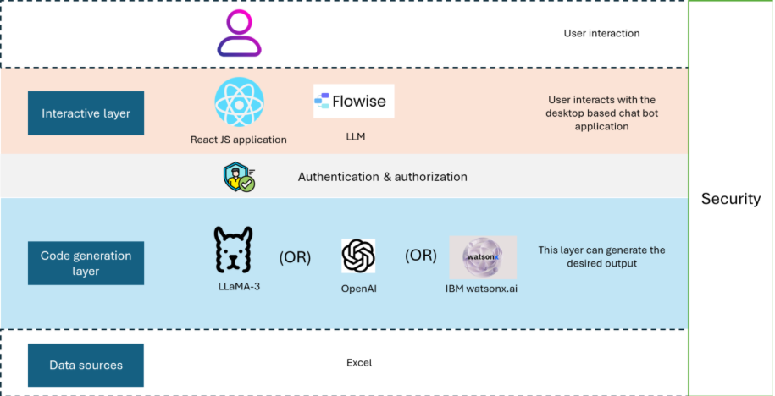

## Flow for NTPC’s on-demand charts generation in the application – *(This can be discussed and agreed upon)*

**1. User Gives a Prompt**

Example:  
*"Show me a bar chart of daily coal procurement cost vs. production cost for the last 30 days"*

Shape**2. Data Source**

We can work in **two ways**:

* **Excel Upload (POC phase)** → NTPC uploads the daily operational Excel sheet into the web app.
* **Live Data Integration (future phase)** → Data fetched directly from ERP/SCADA/logistics systems.

Shape**3. LLM Understanding**

The **LLM reads the prompt** and figures out:

* Which chart type to use (bar, line, scatter, pie, etc.).
* Which columns from the data to plot (e.g., date vs. cost).
* Any special transformations (rolling average, % change, filters).

Shape**4. Chart Code Generation**

The LLM then:

* **Chooses a charting library**:
  + **Plotly.js** → Best for interactive dashboards.
  + **Chart.js** → Simple, lightweight charts.
  + **D3.js** → Fully customizable visuals.
* Generates the chart configuration (title, axes, labels, colors).

Shape**5. Chart Rendering**

The app:

* Uses the chosen library to **render the chart instantly** in the browser.
* Allows the user to:
  + Switch between Plotly, Chart.js, and D3.js views.
  + Zoom, hover, filter.
  + Export as PNG/JPG or embed in a report.

Shape**6. Iteration**

User can refine the prompt:  
*"Now add last year’s data as a comparison"*  
The LLM updates the chart configuration accordingly, without manual coding.

Shape💡 **Benefit for NTPC in POC**

* No manual chart creation in Excel/Power BI.
* Any team member can create visuals just by typing a question.
* Works first with Excel uploads → scales later to live plant data.

## POC Timeline

Week 1 – Data Collection & Setup

* Collect and validate sample datasets (demand, coal quality, stock, cost).
* Set up basic data pipelines (CSV/Excel ingestion).
* Define success criteria (60%+ accuracy, buffer validation).

Week 2 – Baseline Model & Calculations

* Develop baseline coal requirement calculation engine using demand + GCV + heat rate.
* Implement stock buffer check (10–20 days).
* Simple profitability check (tariff vs delivered cost).
* Quick validation on 1–2 plants.

Week 3 – Visualization & Prototype

* Build basic dashboard (demand, stock, coal required, cost vs tariff).
* Run sample scenarios (demand surge, low GCV, delivery delay).
* Share interim results with NTPC team (quick-win checkpoint).
* Deliver POC report + demo.

Week 4 – Optimization engine

* Optimization algorithm development
* Genetic algorithms, Linear Programming
* Time Series

Week 5 – Final Validation & Report

* Refine accuracy and logic based on NTPC feedback.
* Run validation on full sample period (4–8 weeks of data).
* Document results, accuracy levels, and limitations of the POC.

# Overall Understanding from the shared Dataset (Dadri Data)

The objective is to find the best combination of coal suppliers, coal type, multiple chemical property parameters that will minimize the cost of operation and maximize the operational efficiency. Also, this process will be able to streamline the supply chain.

## **1. Coal Procurement EDA**

From the given data input, we analyzed **Daywise_CoalReceipt_C&FCost** sheet and mapped the optimization process relationship as per the POC:

* Plant / Consignee Plant → **plant-level demand & constraints**
* Invoice_No, RR_Receipt_No, Invoice → **transactional traceability**
* RR Quantity, RRCpt → **delivered coal quantity**
* price_per_ton_coal, price_per_ton_freight, price_per_ton_landed → **base commodity + freight + landed cost**
* total_iv_coal_value, total_iv_freight_value → **procurement cost components**
* landed_per_ton, avg_price_per_ton_coal, avg_price_per_ton_detected → **cost normalization & profitability gate**
* share_pct → **sourcing mix / vendor share**

These feed **POC dimensions**: ***Cost & Profitability Parameters, Logistics Data, Stock & Buffer Data*.**

## 

## **2. Coal GCV EDA**

**Daywise_GCVData Data Analysis:**

These link to **Coal Quality & Blend Optimization**:

* Plant / Consignee Plant → **demand–quality mapping**
* Coal Vendor, Vendor → **supplier reliability dimension**
* Coal Grade At The Time Of GR, Grade → **coal quality classification**
* Gross Calorific Value, avg_gcv, max_gcv → **core quality driver for coal requirement calc**
* Moisture, Ash, VM (Volatile Matter) → **quality attributes affecting boiler efficiency**
* Quantity, Qty, avg_qty_per_record → **supply–demand reconciliation**
* Entry Dt, Sample Date → **time-based quality trends, useful for forecasting**

These feed **POC dimensions**: *Coal Quality & Blend Parameters, Risk & Compliance Parameters (ash %, blending rules)*.

**Combined “Critical Factors” for the POC**

From both EDAs, the **priority factors** that directly power the POC system are:

1. **Demand & Plant Ops**

Plant, Consignee Plant, RR Quantity

1. **Coal Quality**

Gross Calorific Value, Moisture, Ash, VM, Grade

1. **Cost & Profitability**

price_per_ton_coal, price_per_ton_freight, price_per_ton_landed, landed_per_ton

1. **Stock & Buffer**

Quantity, avg_qty_per_record, total_iv_coal_value, total_iv_freight_value

1. **Logistics & Risk**

RR_Receipt_No, Invoice_No (traceability) , Vendor fields → Coal Vendor, Vendor

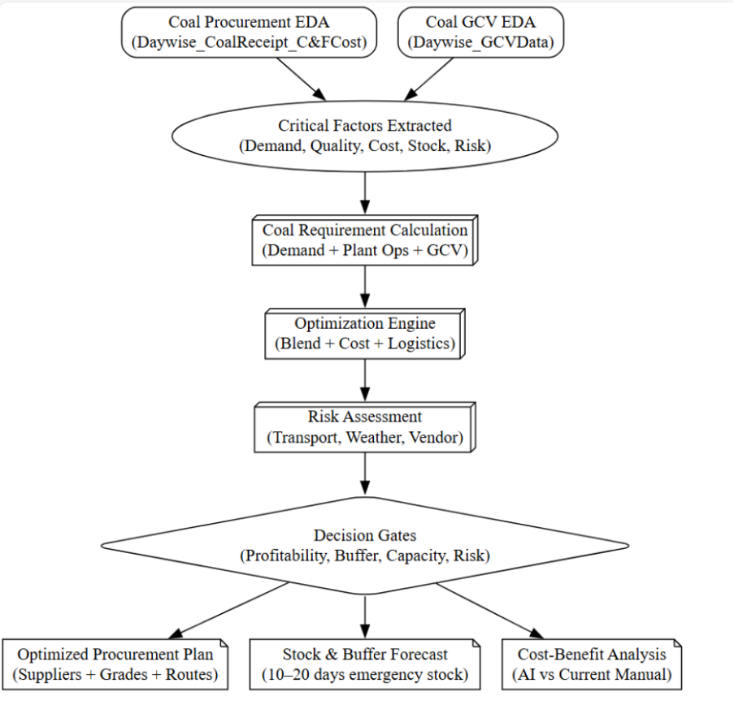

*fig 3: Optimization process*

# Commercials

The commercials for the POC – Optimization are proposed based on the requirements of domain expertise, Core Data Science expertise and GenAI expertise. The POC requires sufficient complete power to train the model and deploy the model.

An optimal cost structure is proposed as shown below :

|  |  |  |
| --- | --- | --- |
| **Category** | **Description** | **Amount (INR)** |
| Consulting Charges |  |  |
|  | Strategic Business Consulting | 20000 |
|  | Domain Expertise Consulting | 50000 |
| Engineering Charges |  |  |
|  | Compute Hardware charges | 50000 |
|  | Software Tools/Development Fees | 15000 |
|  | Technical Testing & Validation | 15000 |
| Manpower |  |  |
|  | Core Data Science Team | 1680000 |
|  | GenAI Architect | 400000 |
|  | DevOps staff | 200000 |
| Travel |  |  |
|  | Domestic Travel | 50000 |
|  | Accommodation & Daily Allowances | 15000 |
|  | Misc. Travel Expenses | 5000 |
| Grand Total |  | 2500000 |